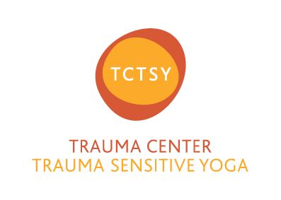

Trauma Center Trauma-Sensitive Yoga (TCTSY) is an empirically validated, adjunctive clinical treatment for complex trauma or chronic, treatment-resistant PTSD. Developed at the Trauma Center in Brookline, Massachusetts, TCTSY has foundations in Trauma Theory, Attachment Theory, and Neuroscience as well as deep roots in Yoga.

TCTSY timeline:

- Began in 2003
- 2009 Received first grant given by National Institute of Health to study yoga for trauma
- 2014 published results in peer-reviewed, psychiatric journal (http://www.traumacenter.org/products/pdf_files/Yoga_Adjunctive_Treatment_PTSD_V0001.pdf)
- 2017 Listed by SAMHSA as an evidence-based practice (http://nrepp.samhsa.gov/ProgramProfile.aspx?id=144#hide4)

Key research findings:

- 10-weeks of TCTSY reduced PTSD symptoms 33% in women, 18-59 years old, with childhood physical and sexual abuse.
- Two months post treatment, 52% of the women no longer qualified for PTSD diagnosis. (http://www.traumacenter.org/products/pdf_files/Yoga_Adjunctive_Treatment_PTSD_V0001.pdf)
- 20-weeks of TCTSY reduced PTSD symptoms 45% in women, 18-59 years old, with childhood physical and sexual abuse.
- 20-weeks of TCTSY significantly reduced dissociative symptomatology. (http://www.traumacenter.org/products/pdf_files/Effectiveness_Extended_Yoga_Treatment_Women_Chronic_PTSD_P0005.pdf)

For more information, please visit www.traumasensitiveyoga.com

